AY:2024/25: SPRING SEMESTER
ITSE204 /CSSE2205
DIPLOMA COURSE PROJECT
FINAL REPORT

Project Title:
Online Parking Booking System

Submission Date:14-5-2025

Abstract

The Parking Booking System is an online platform designed to streamline the process of finding and reserving parking spaces. The primary objective of this project is to help customers locate and book parking spots efficiently, reducing time wastage and minimizing traffic congestion. The system utilizes the Agile methodology to ensure the development of a reliable and user-friendly solution. It enables users to search for available parking spots, make reservations, and complete payments online, eliminating the need for manual transactions and cash payments. By enhancing convenience and reducing the effort required to find parking, this system contributes to smoother traffic flow and improved urban mobility.

Table of Contents
Chapter 1: Introduction 6
1.1 Introduction 6
1.2 Problem Statement 6
1.3 Project Scope and Limitations 6
1.4 Project Objectives 7
1.5 Project Description 8
1.6 Significance of the project 9
1.7 Project Methodology 10
Chapter 2: Background study and Requirement details 11
2.1 Background study 11
2.1.1 Research One 11
2.1.2Research Two 12
2.2 Hardware requirements 13
2.3 Software requirements 13
2.4 Functional Requirement 13
2.5 Non-Functional Requirement 14
Chapter 3: Project plan 15
3.1 Action Plan 15
3.2 Tracing Sheet 16
3.3 Questionnaires with analysis 19
Chapter 4: Analysis and design 24
4.1 Data Flow Diagram (DFD) 24
Context level- 24
Level 1- 25
4.2 Normal forms 26
4.3 Table Design 27
4.4 Entity Relationship Diagram (ERD) 30
4.5 Navigation Diagram 31
Chapter 5: Implementation 32
5.1 Screen Design with Navigation Links 32
Chapter 6: Testing 57
6.1 Introduction/Concepts 57
6.2 Final test cases 58
Chapter 7: Conclusion and Future Work 58
Chapter 8: Roles and Contributions of the Student Group 65
Appendices- 66
References 66

Chapter 1: Introduction

Introduction

As cities grow and more cars fill the roads, finding a parking space has become a daily struggle for drivers. Traditional parking methods are plagued by crowded spaces, limited spaces, and the hassle of carrying cash or tickets. To solve this problem, an online parking system was created. Through a simple website, users can search, reserve, and pay for parking spaces in advance. The system displays parking spaces, offers secure payments, and helps drivers navigate easily, reducing traffic jams caused by parking searches. This online system saves time, reduces stress, and guarantees a parking space when needed.

Problem Statement

In Oman, there is no online parking system to assist drivers in finding and booking parking spaces. Therefore, many drivers struggle to find available parking, resulting in increased traffic, wasted time, and frustration. Frequently, parking lots are full when drivers arrive, since they cannot check availability in advance. The search process is also lengthy due to the lack of services for booking parking spaces in advance.
Another challenge is the reliance on cash payments, which requires drivers to carry cash and manage change. Manually managing parking spaces often leads to overcrowding and financial losses for parking lot Admins. Customers also do not have access to a feedback platform, which could improve customer service.

Project Scope and Limitations

The Parking Booking System is a web-based platform designed to simplify the process of finding, reserving, and paying for parking spaces online. The system aims to reduce the time wasted in searching for parking spots and help minimize traffic congestion. The scope of this project includes:
- User Registration and Authentication– Customers can create accounts to manage their parking reservations.
- Parking Spot Search and Reservation – Users can view available parking spaces and book them in advance.
- Online Payment Integration – Secure payment options allow users to pay for parking online, reducing the need for cash transactions.
- Admin Dashboard– Parking lot Admins or administrators can manage parking availability, pricing, and reservations.
- Real-Time Availability Updates– The system updates parking space availability to prevent overbooking.
This system is intended for drivers looking for parking spaces and parking lot administrators managing their facilities.
While the Parking Booking System provides a convenient solution, it has some limitations:
- Internet Dependency – The system requires an active internet connection to function properly.
- Limited to Participating Parking Lots – Only parking locations that are registered in the system will be available for booking.
- No Real-Time Vehicle Detection– The system does not automatically detect vehicle entry/exit; it relies on user input or manual confirmation by the parking staff.
- No AI-Based Parking Predictions– While the system shows current availability, it does not predict future parking availability based on trends.

Project Objectives

This project aims to develop an Online Parking Management System that simplifies finding, reserving, and paying for parking spaces. By integrating real-time updates, seamless booking, and secure payments, the system will enhance efficiency and improve the overall parking experience for users and administrators.
Objectives-
- Develop an Online Parking Management System to streamline parking reservations and payments.
- Enhance efficiency by enabling users to:
  - Browse available parking spots in real-time.
  - Book parking spaces in advance.
  - Complete secure online payments, eliminating physical tickets and cash.
- Provide key features, including:
  - Real-time availability updates.
  - A seamless and user-friendly booking process.
  - An intuitive interface for both users and administrators.
- Enable users to:
  - Receive booking confirmations.
  - View generated receipts.
  - Provide feedback on their parking experience.
- Admin functionalities:
  - Manage bookings and parking slots.
  - Oversee payment-related issues.
- Overall goal:
  - Offer a hassle-free parking experience.
  - Reduce traffic congestion.
  - Promote smarter urban mobility.

Project Description

An online parking system allows users to find, reserve, and pay for parking spaces through a user-friendly website. This system is designed to help customers easily locate available parking spots, book them in advance, and make payments without the need for physical tickets or cash.
The Online Parking Management System provides a smooth and hassle-free parking experience. Customers can easily register on our website by entering essential details such as their name, email, phone number, and password. After logging in, they can browse available parking spaces.
To book a parking space, users must fill out a simple form with their vehicle details and contact information. Payments are processed securely online via credit card, ensuring the confidentiality of user details. Credit card information can also be stored for future use. After completing the payment, a confirmation page will display the parking details and expected arrival time. A report will be generated, and customers will have the option to provide feedback about their experience.
Additionally, an admin is responsible for managing the system and handling issues related to bookings, parking slots, and payments.
This system eliminates the difficulty of finding parking, reduces traffic congestion, and ensures a smooth, stress-free experience with real-time availability and secure payments. It is perfect for daily drivers, event attendees, or anyone in need of convenient parking.

Significance of the project

The Online Parking Management System provides many advantages for customers, parking Admins, employees, managers, and other stakeholders involved.
- Customer Benefits:
Convenience: Customers can easily find and book parking spots from their homes using mobile devices without the need to drive around for a long time searching for a parking space.
Timesaving: By reserving parking in advance, customers avoid wasting time searching for available spots to park.
Flexibility: Customers can choose their preferred parking spots that best fit their schedules and needs.
Reminders & Notifications: Automated notifications to remind customers of their bookings, to help them avoid missing an appointment.
- Benefits for Managers:
Simplified Operations: Managers can easily manage parking bookings through a single online system, reducing manual tracking and improving efficiency in managing parking spaces.
Performance Tracking: Managers can see real-time data on parking usage, busy times, and customer feedback, which helps them make improvements where needed.
Scalability: As demand for parking increases, the online system can easily expand to add more locations or grow into other cities.
- City/Urban Planning Benefits:
Reduced Traffic Congestion: By ensuring drivers have access to guaranteed parking, the system reduces traffic jams, improving overall traffic flow.
Environmental Impact: Fewer cars driving around looking for parking means less fuel consumption and reduced emissions, contributing to a cleaner environment.
Smoother City Travel: Making parking easier to manage, helps traffic move more smoothly and reduces transportation problems in the city.
In conclusion, managers, customers, and urban planners all benefit greatly from the Online Parking Management System. By offering consumers flexibility, time savings, and convenience, it improves the parking experience. Simplified operations, real-time tracking, and scalability due to demand are all beneficial to managers. Additionally, by lowering pollutants, enhancing public transportation, and reducing traffic congestion, the system helps improve city planning. This technology-enabled system offers a smooth, effective, and environmentally friendly solution that improves parking.

Project Methodology
We have chosen the Agile methodology for this project, as it offers an incremental and iterative approach to software development. Agile facilitates adaptability, continuous testing, and feedback integration by breaking the project into manageable components. The development process will follow these key steps:
- Requirement Gathering – Collect user and admin details (e.g., name, phone number, username, password) to tailor the web application accordingly.
- Analysis and Design – Structure and plan the web application based on gathered data and discussions.
- Development – Code the application using Notepad++ and run it in a browser with WAMP tools.
- Testing – Identify and fix bugs to ensure a smooth and user-friendly experience.
- Enhancements & Updates – Incorporate user feedback, debug, and refine the application for optimal performance.
This structured approach ensures a robust, user-friendly, and efficient parking management system.
AGILE MODEL

Chapter 2: Background study and Requirement details

2.1 Background study

2.1.1 Research One
Introduction-
Spot Hero is an online service that allows for parking bookings in key cities throughout the U.S. and Canada. It provides users with the ability to search for, reserve, and pay for parking in advance. This review contrasts Spot Hero with ParkNBook, highlighting both the similarities and distinctions in their features.
Main body-
Both Spot Hero and ParkNBook offer online reservation services, enabling users to search for and secure parking in advance. Nevertheless, while Spot Hero provides parking in a variety of locations, such as airports and event spaces throughout North America, ParkNBook is concentrated on hourly reservations for shopping malls in Oman.
Spot Hero accommodates various parking categories, including hourly, monthly, airport, and event parking, but is limited to personal vehicles. On the other hand, ParkNBook accepts all types of vehicles and enhances flexibility by including VIP, EV, and handicap parking options. Furthermore, ParkNBook's targeted strategy specifically addresses mall customers in Oman, making it a localized and convenient choice. In contrast, Spot Hero, with its extensive range, is more appropriate for individuals seeking parking solutions in various urban environments across North America.
Conclusion-
Spot Hero and ParkNBook share the goal of streamlining parking reservations. While Spot Hero offers extensive coverage, ParkNBook excels in tailored services for Oman’s malls. The focus on specialized parking options gives ParkNBook a distinct edge in its target market.
References-
Andrea. (2020, August 3). SpotHero insurance and parking tips. Retrieved on March 12, 2025 from https://blog.spothero.com/insurance-and-parking/

2.1.2Research Two
Introduction-
Locating a parking space can be challenging, but services like Park Click and ParkNBook facilitate the process by enabling users to book parking spaces ahead of time. While both platforms aim to streamline parking, they address distinct needs and areas. This review evaluates their features, coverage, and overall user-friendliness.
Main body-
Park Click offers parking facilities in numerous locations, such as airports, downtown areas, and event sites. It is aimed at individual car Admins seeking a swift and convenient method to secure parking in crowded regions. Conversely, ParkNBook is tailored specifically for malls in Oman, providing hourly bookings designed for shoppers. A significant distinction lies in the types of vehicles they accommodate. Park Click mainly caters to standard cars, while ParkNBook accepts all vehicle categories, including VIP, electric vehicles, and accessible parking spots, ensuring inclusiveness for various users. Though Park Click covers a wider area, ParkNBook is shaped for a more localized demographic, delivering specialized services for frequent mall visitors. This focused strategy makes it a practical option for those who prefer a hassle-free parking experience at shopping centres.
Conclusion-
Both platforms assist users in finding parking, yet they have different functions. Park Click is suited for individuals who require parking across diverse urban settings, while ParkNBook are an excellent option for shoppers in Oman seeking a dedicated parking solution for malls. The decision hinges on the user's specific parking requirements.

References
Parclick. (n.d.). City centre, airport, station and beach parkings | Parclick. Retrieved on March 12, 2025 from https://parclick.com/

Hardware requirements

Hardware | Minimum | Maximum
Memory | 2GB | 8GB
Processor | Intel Pentium 4 | More than Intel Core 4
RAM | 2GB | higher
Keyboard | S/2 Keyboard | -

Software requirements
Software | Description
PHP | A general-purpose scripting language for developing dynamic and interactive websites.
HTML | Used for structuring web pages.
Lucidchart.com | Used to draw Data Flow Diagrams (DFD)
Web Expresser | A design tool for creating websites using PHP and HTML.
Notepad++ | A tool for writing and editing code.
Microsoft Project | Used for scheduling, resource distribution, and budget management.
Microsoft Word | Used to write project reviews and documentation.
Microsoft PowerPoint | Used to creating and delivering presentations.
Canva | Used to create a wide variety of visual content.
WAMP Server 64 | A Windows web development environment that allows web applications to run with Apache2, PHP, and MySQL.
ERDPlus.com | Used to draw Entity-Relationship Diagrams (ERD).

Functional Requirement
1.User Authentication: The system enables both customers and administrators to log in securely using their credentials, granting access to features based on their roles.
2. Parking Availability Viewing: The system allows customers to browse and view real-time availability of parking spaces and related services, helping them plan and choose suitable options.
3. Parking Reservation System: The system allows customers to book parking spots by selecting specific locations, dates, and times, streamlining the reservation process for convenience and accuracy.
4.Payment Integration: The system supports multiple payment methods, including credit card transactions and other digital payment options, to ensure flexibility for customers.
5. Secure Payment Data Entry: The system allows when payment is by credit card, customers are required to enter their personal and bank account information securely to complete the transaction.
6. Booking Confirmation: Once a booking is successfully made, the system automatically sends a confirmation message or email to the customer with booking details.
7. Administrative Reporting Tools: The system allows administrators to have access to detailed reports that include information on bookings, parking space usage, and customer data for operational oversight.
8. Parking Spot Management: The system allows admins to add new parking spots, update prices, or remove outdated entries, giving them full control over the parking lot.
9. Customer Information Access: The system allows admins to view user profiles and customer details, which is essential for account management and support purposes.

Non-Functional Requirement
1. High Availability: The system must operate 24/7 without downtime to ensure customers can access services anytime, especially during peak hours or emergencies.
2. Password Policy Enforcement: User passwords must meet strict criteria, including at least one uppercase letter, four lowercase letters, and three numbers, to enhance account security.
3. Data and Transaction Security: The system must protect all user information and financial transactions using encryption and secure protocols to prevent unauthorized access or breaches.
4. Transaction Timeout: To avoid processing errors or fraudulent activity, the system automatically cancels any payment process not completed within 30 seconds.
5. User-Friendly Interface: The platform must offer a clean, intuitive, and easy-to-use interface that accommodates users of varying technical skill levels.
6. Responsive Design: The system must adapt seamlessly across devices such as desktops, tablets, and smartphones, ensuring consistent functionality and layout.
7. Browser Compatibility: The application must support all major web browsers, including Google Chrome and Microsoft Edge, to provide consistent experience for all users.

Chapter 3: Project plan

Action Plan

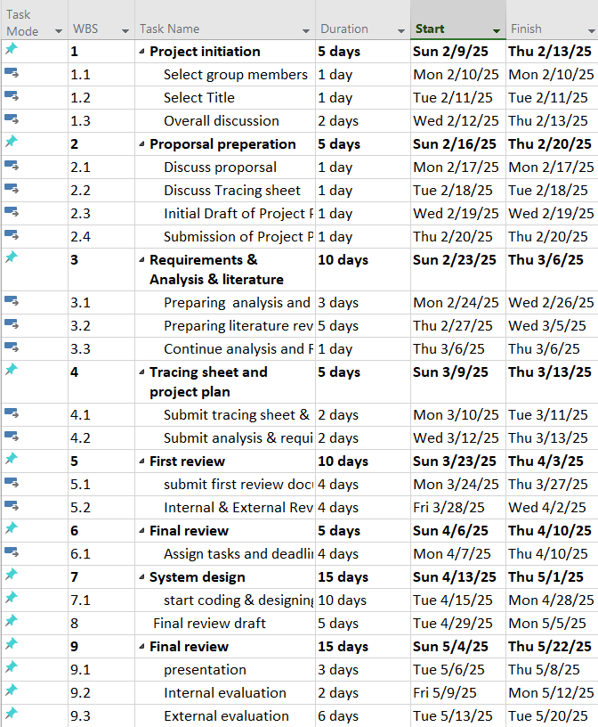

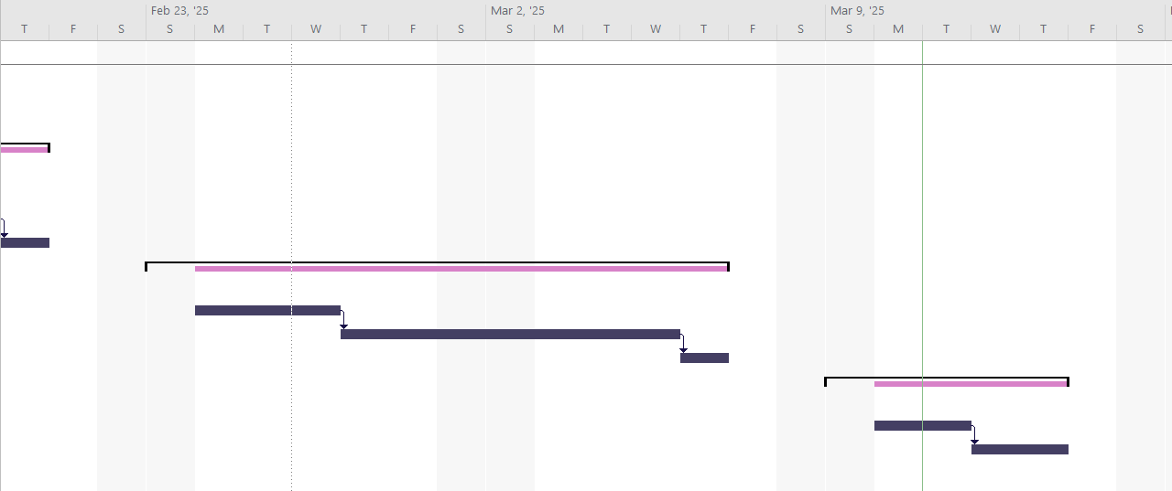

Tracing Sheet

Module Id | Module Name and Short Description | Priority (L, H) | Reference in DFD | Reference in SDD | Reference in the test cases | Comments  by reviewers
Module 1 | Registration
M1F1 | Customers can register and create a profile. | H | 1.0 | Figure 2 | Case 1
Module 2 | Login
M2F1 | Customers' login email and password. | H | 2.0 | Figure 3 | Case 2
M2F2 | Password encryption | L
M2F3 | Forget password with email. | L |  | Figure 3
Module 3 | Parking Availability Search
M3F1 | Customers can check for available parking spaces in real-time within the parking lot. | H | 3.0 | Figure 5
Module 4 | Booking
M4F1 | Customers can book a parking spot in advance. | H | 4.0 | Figure 5 | Case 5
M4F2 | Customers book parking for a particular time. | H |  | Figure 5 | Case 5
Module 5 | Payment
M5F1 | Customers pay for parking via various methods (credit card/debit card/and more). | L | 6.0 | Figure 6
Module 6 | Feedback
M6F1 | Customers can send feedback. | H | 7.0 | Figure 7 | Case 4
Module 7 | Admin Management
M7F1 | Admin can update, delete, or add parking details | H | 8.0 | Figure 10 | Case 3
M7F2 | Admins can access user profiles. | H | 8.0 | Figure 10 | Case 3
M7F3 | Admin can view bookings. | H |  | Figure 10
M7F4 | Admin can view customer feedback. | H |  | Figure 10
Module 8 | Report
M8F1 | Admin generates reports (customer profile, parking details, feedback, booking) | L | 9.0 | Figure 10

3.3 Questionnaires with analysis

The chart shows that most respondents, approximately 68%, would use an online system to find and book parking in advance, while around 16% are unsure, and 16% would not use it.

The chart shows that around 84% of respondents have missed an appointment or been late due to parking difficulties, while 11% have not faced this issue, and 5% would not face.

The chart shows that majority 99% of respondents believe an online parking system would help reduce traffic.

The chart shows that most respondents, about 80% drive a car, while 10% ride a motorcycle, and 10% drive other types of vehicles.

The chart shows that the majority of respondents, approximately 74%, prefer cashless payment options for parking, while around 26% do not.

The chart shows that around 53% of respondents drive and need parking daily, while 37% need parking a few times a week, and 11% require it occasionally.

The chart shows that approximately 63% of respondents sometime struggle to find parking, while 26% always struggle, 11% rarely face difficulties.

The chart shows that the biggest parking challenges faced by respondents include overcrowded parking 43%, limited parking spaces 41%, high parking fees 8%, and difficulty in making payments 8% .

- What improvements would you like to see in the parking management system?
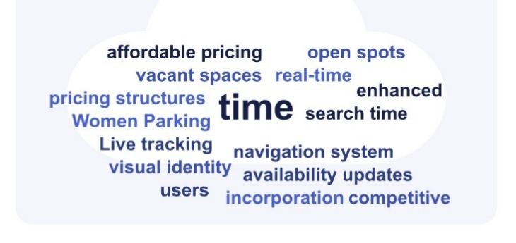

(These responses indicate a demand for better efficiency, pricing transparency, and improved accessibility in parking management.)

- What features would you find most useful in an online parking system, AND why?

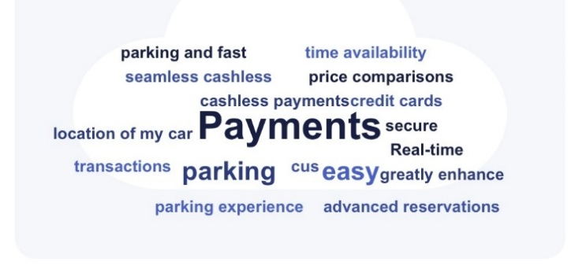

(These responses indicate a demand for seamless cashless payments, real-time availability, price comparisons, and improved parking location tracking for a more convenient experience.)

Chapter 4: Analysis and design

4.1 Data Flow Diagram (DFD)

Context level-

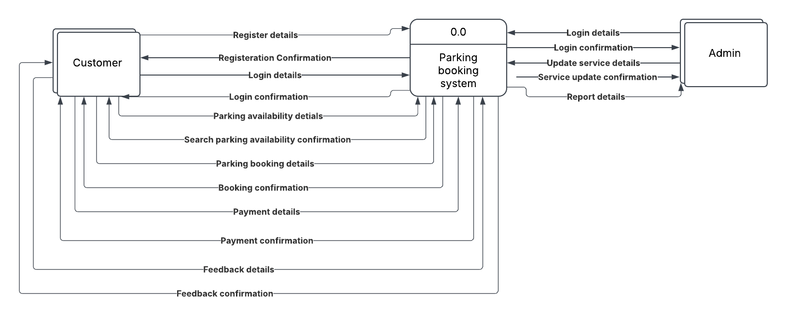

Level 1-
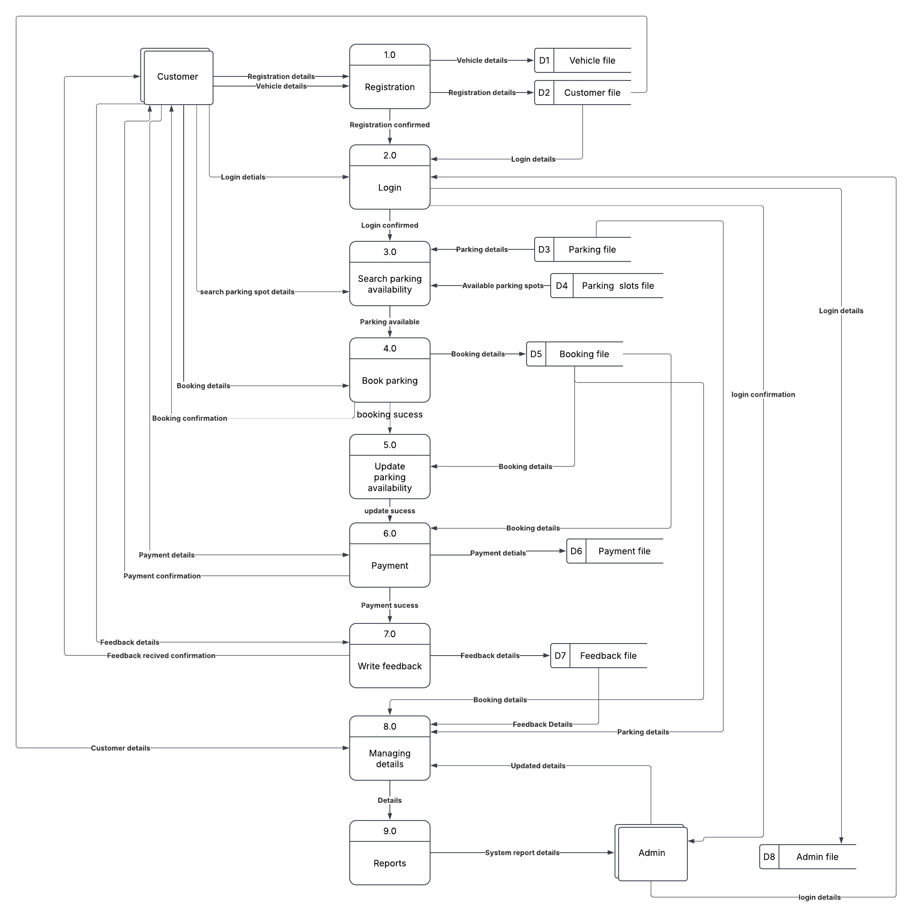

4.2 Normal forms
UNF | 1NF | 2NF | 3NF | Table Name
Cid  Cname  Email  Psd  Phone  Vno  Type  Model  Id  Name  Price  Id  Start_Time  End_Time  Slot_Date  Id  Booking_Date  Start_Time  End_Time  Fid  Rating  Feedback  Card_Number  Cvv  Expiry_Date  Total_Payment | Cid  Cname  Email  Psd  Phone | Cid (Pk)  Cname  Email  Psd  Phone | Cid (Pk)  Cname  Email  Psd  Phone | Customer
 | Vno  Type  Model  Id  Name  Price  Id  Start_Time  End_Time  Slot_Date  Id  Booking_Date  Start_Time  End_Time  Fid  Rating  Feedback  Card_Number  CVV  Expiry_Date  Total_Payment | Vno(PK)  Cid (FK)  Type  Model | Vno(PK)  Cid (FK)  Type  Model | Vehicle
 |  | Id (PK)  Name  Price  Id (PK)  Parking_Id (FK)  Start_Time  End_Time  Slot_Date | Id (PK)  Name  Price | Parking
 |  | Id (PK)  Booking_Date  Start_Time  End_Time  Slot_Id (FK)  Parking_Id (FK)  Cid (FK)  Vno (FK) | Id (PK)  Parking_Id (FK)  Start_Time  End_Time  Slot_Date | Parking Slots
 |  | Fid(PK)  Cid(FK)  Rating  Feedback  Card_Number(PK)  Booking_ID(FK)  CVV  Expiry_Date  Total_Payment | Id (PK)  Slot_Id (FK)  Parking_Id (FK)  Cid (FK)  Vno (FK)  Booking_Date  Start_Time  End_Time | Bookings
 |  |  | Fid(PK)  Cid(FK)  Rating  Feedback | Feedback
 |  |  | Card_Number(PK)  Booking_ID(FK)  CVV  Expiry_Date  Total_Payment | Payment

Table Design

Customer
Field Name | Data Type | Size | Constraints | Remark
Cid | INT | 8 | PRIMARY KEY
Cname | VARCHAR | 30 | NOT NULL
Email | VARCHAR | 50 | UNIQUE
Psd | VARCHAR | 255 | NOT NULL
Cid | INT | 8 | PRIMARY KEY

vehicle
Field Name | Data Type | Size | Constraints | Remark
Vno | VARCHAR | 20 | PRIMARY KEY
Cid | INT | 8 | FOREIGN KEY
Type | VARCHAR | 20 | NOT NULL
Model | VARCHAR | 30 | NOT NULL

Parking
Field Name | Data Type | Size | Constraints | Remark
Id | INT | - | PRIMARY KEY
Name | VARCHAR | 255 | NULL
Price | INT | - | NULL

Parking slots
Field Name | Data Type | Size | Constraints | Remark
Id | INT | - | PRIMARY KEY
Parking_Id | INT | - | NOT NULL
Start_Time | TIME | - | NOT NULL
End_Time | TIME | - | NOT NULL
Slot_Date | DATE | - | NULL

Bookings
Field Name | Data Type | Size | Constraints | Remark
Id | INT | - | PRIMARY KEY
Slot_Id | INT | - | NULL
Parking_Id | INT | - | NULL
Cid | INT | - | NULL
Vno | VARCHAR | 20 | NOT NULL
Booking_Date | DATE | - | NULL
Start_Time | TIME | - | NOT NULL
End_Time | TIME | - | NOT NULL

Feedback
Field Name | Data Type | Size | Constraints | Remark
Fid | INT | - | PRIMARY KEY
Cid | INT | - | NOT NULL
Rating | INT | - | NOT NULL
Feedback | VARCHAR | 255 | NULL

Payment
Field Name | Data Type | Size | Constraints | Remark
Card_Number | INT | - | PRIMARY KEY
Booking_ID | INT | - | NULL
CVV | INT | - | NOT NULL
Expiry_Date | DATE | - | NOT NULL
Total_Payment | FLOAT | 10,2 | NOT NULL

Admin
Field Name | Data Type | Size | Constraints | Remark
Aid | INT | - | PRIMARY KEY
Email | VARCHAR | 50 | NOT NULL
Psd | VARCHAR | 255 | NOT NULL

Entity Relationship Diagram (ERD)

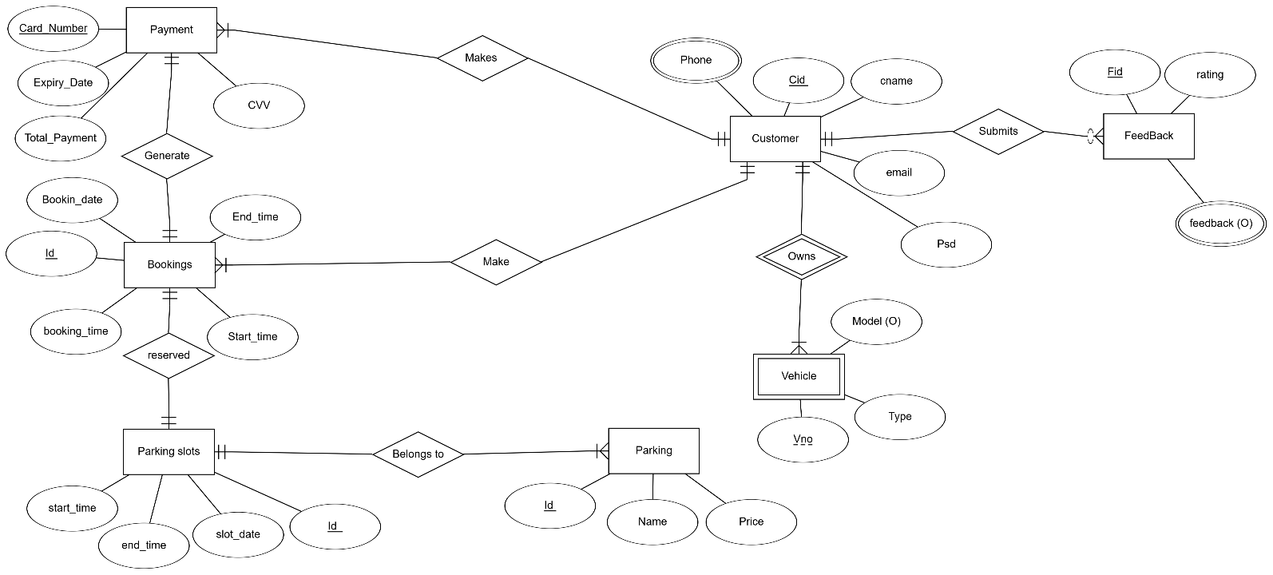

4.5 Navigation Diagram

Chapter 5: Implementation

5.1 Screen Design with Navigation Links

Figure 1
This is A welcoming page where users can explore the features of the parking system and get started and have contact details.

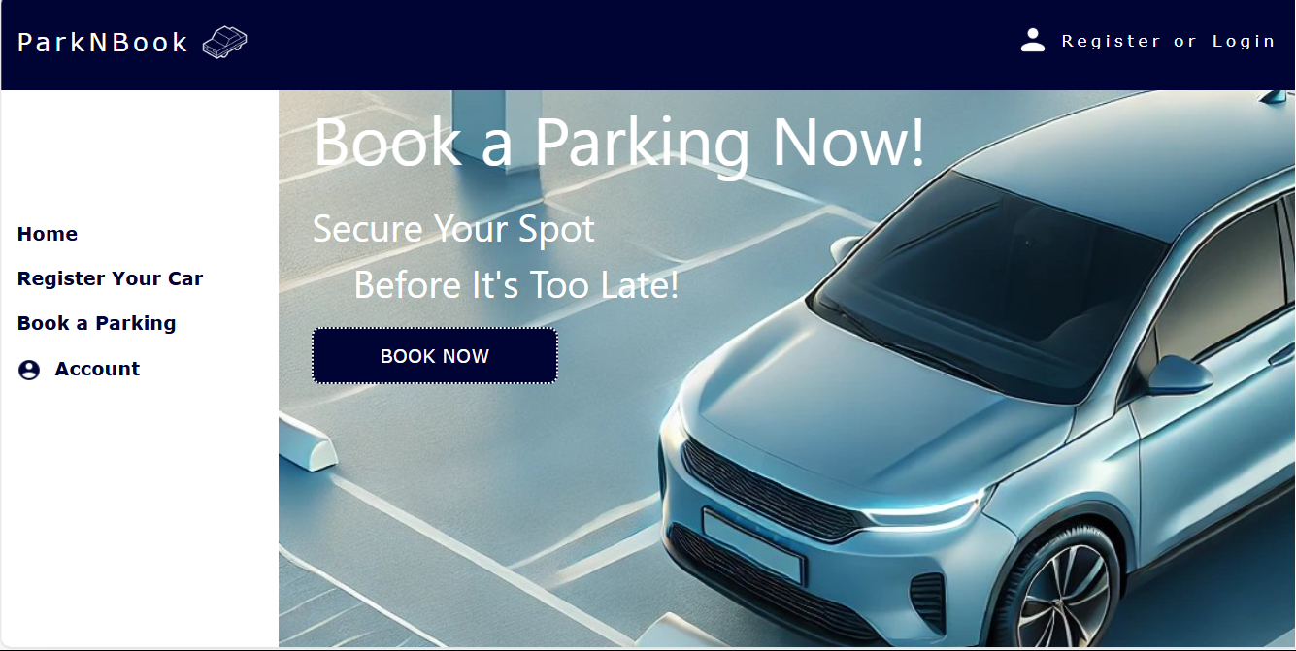
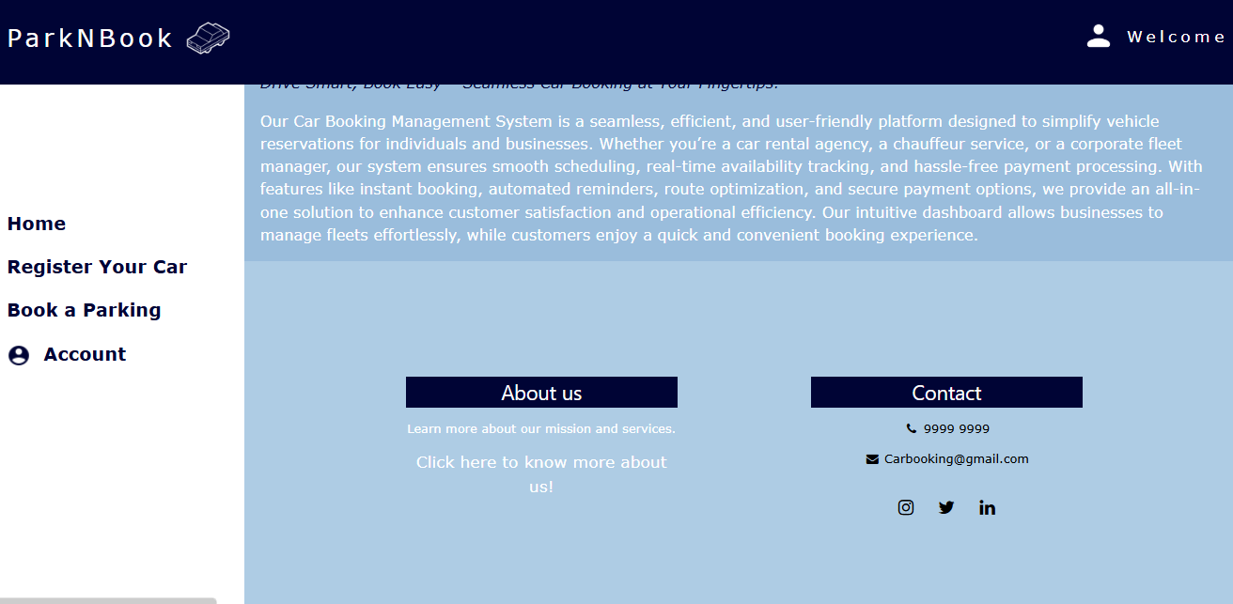

Figure 2
Allows new users to sign up by entering personal and contact information.
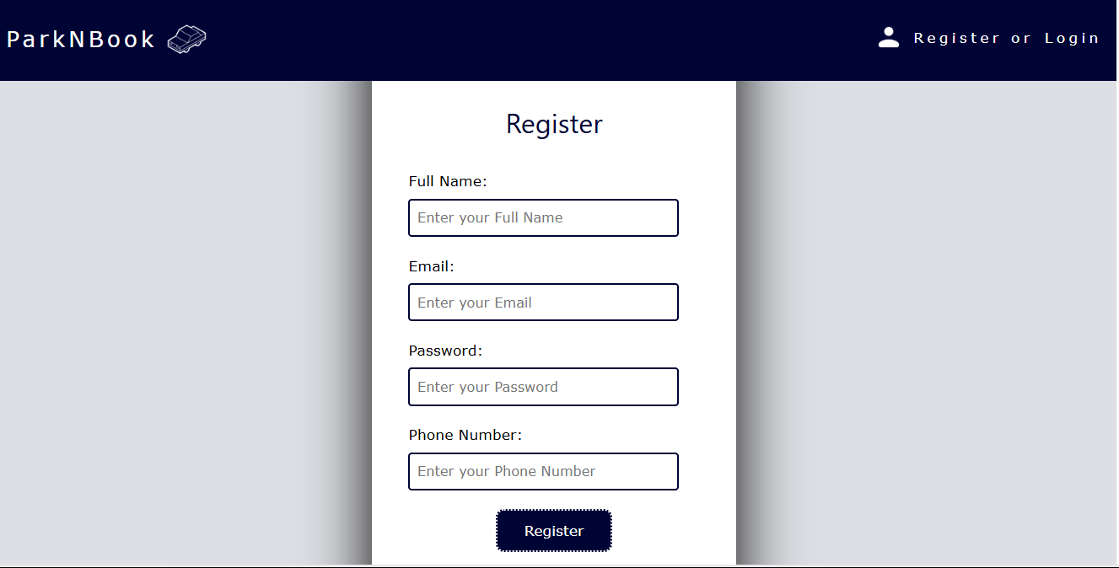

Figure 3
Provides secure access for registered users to log into their accounts.
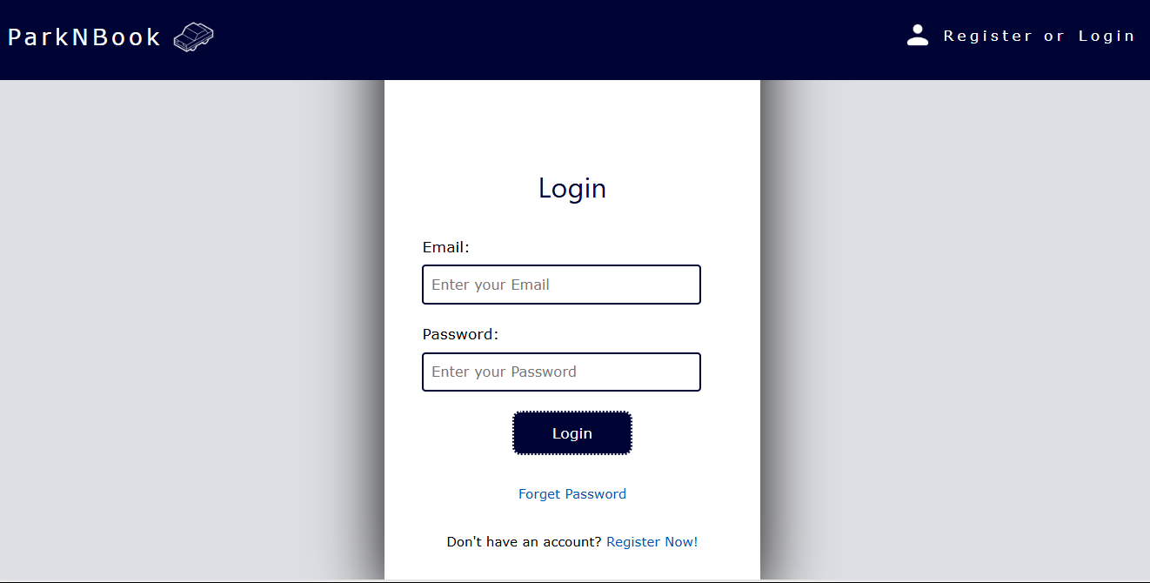
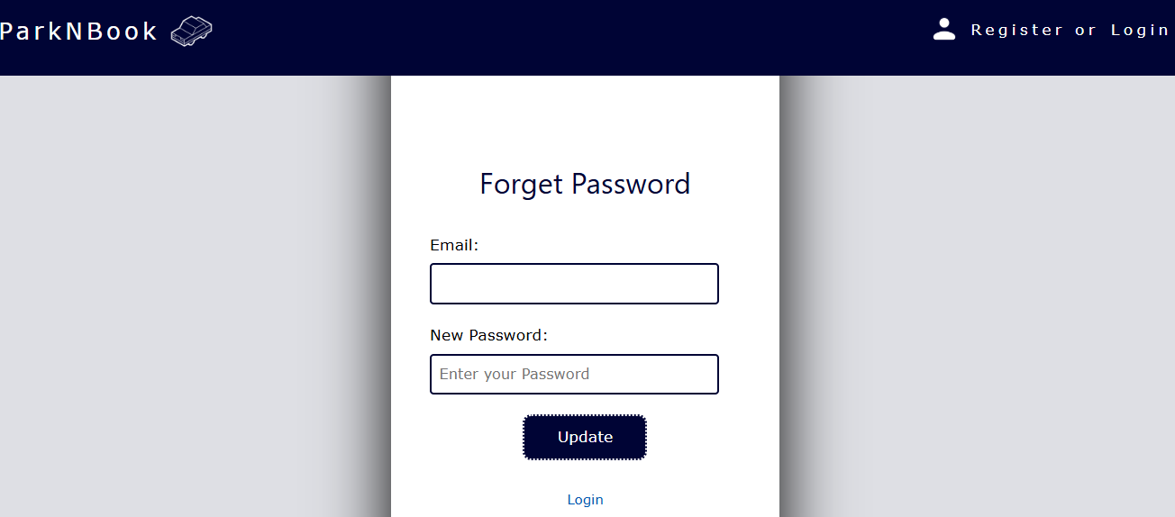
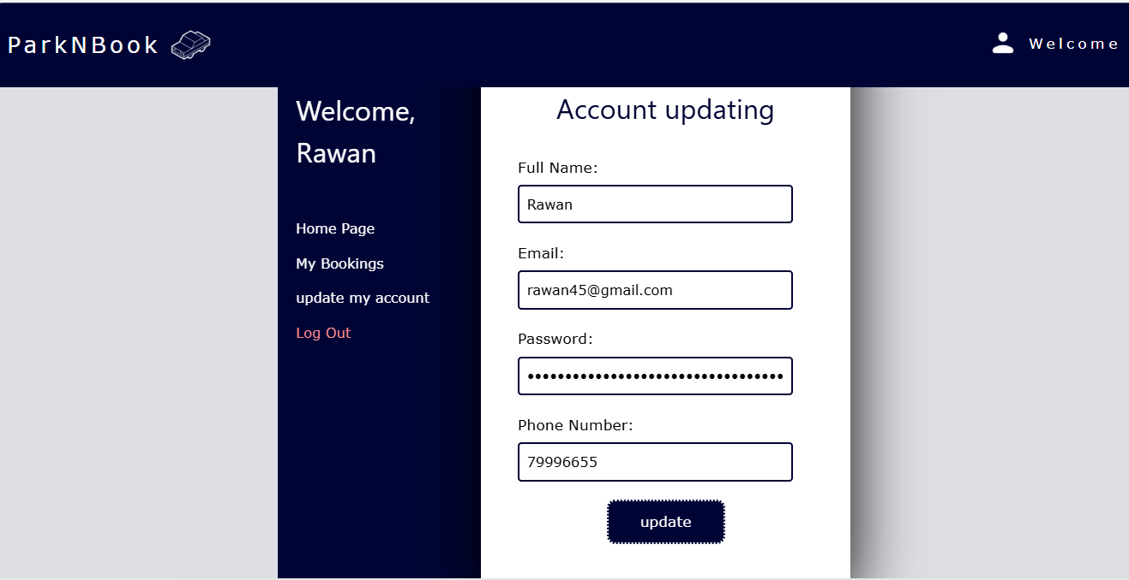
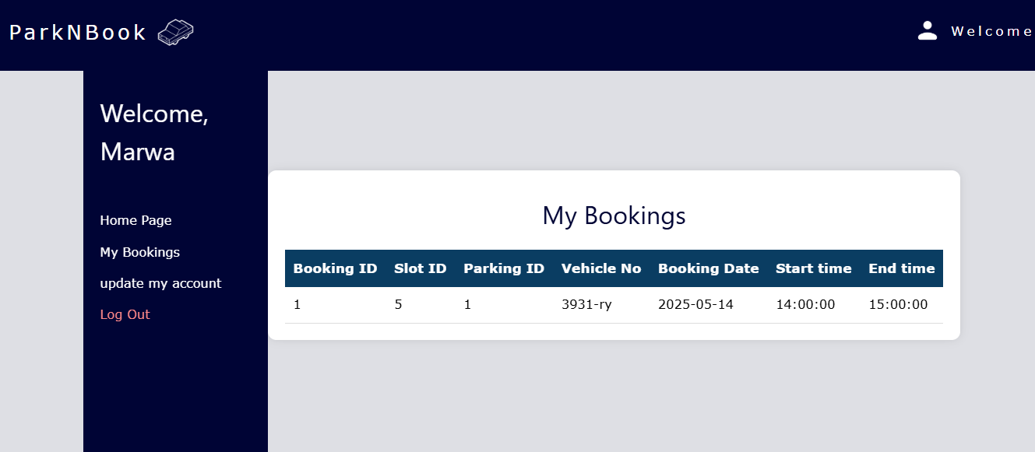

Figure 4
Let customers register their vehicle details to link with parking bookings.
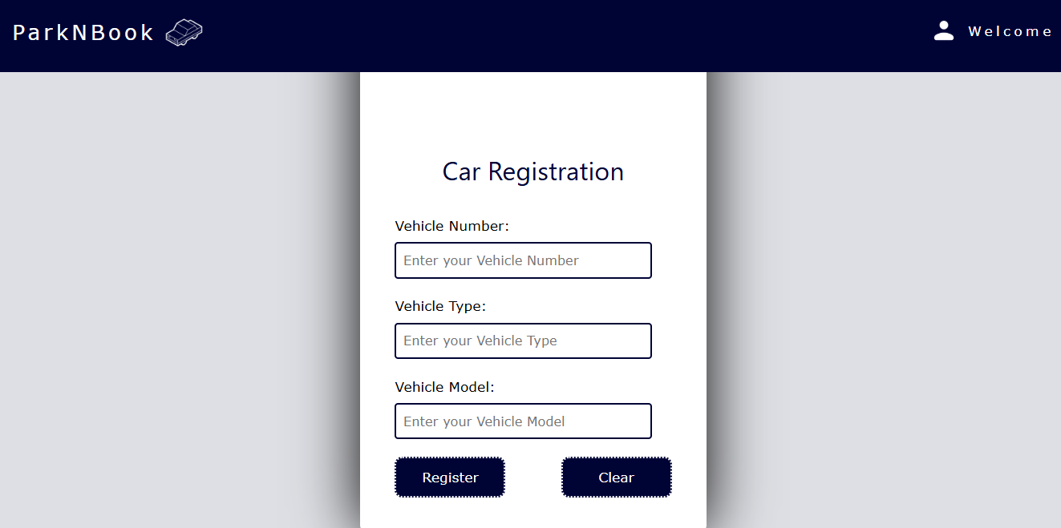

Figure 5

Customers can select a parking slot, choose entry and exit times, and confirm their booking with a click.

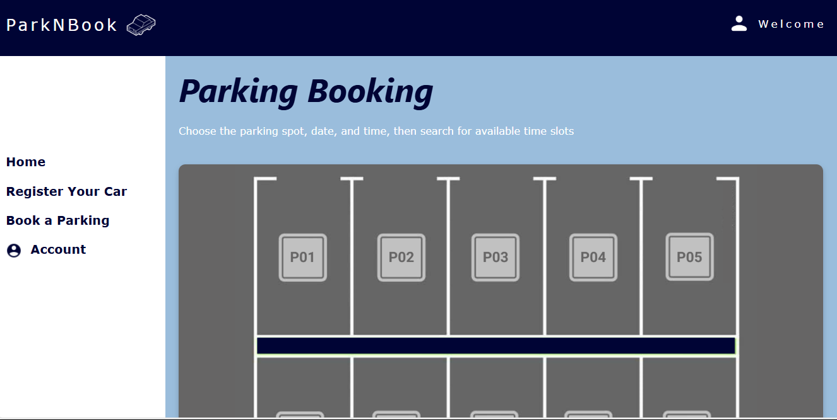
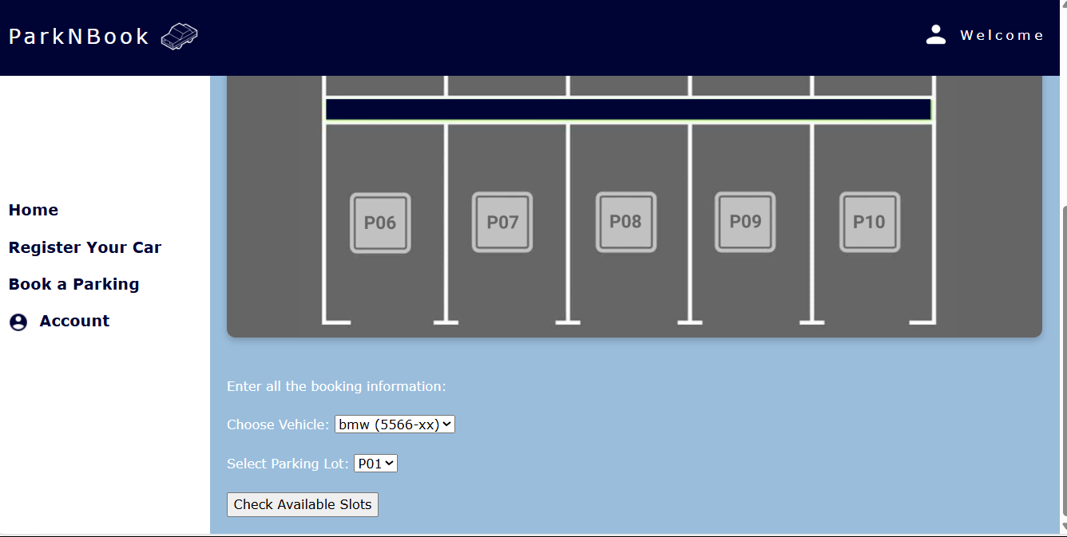
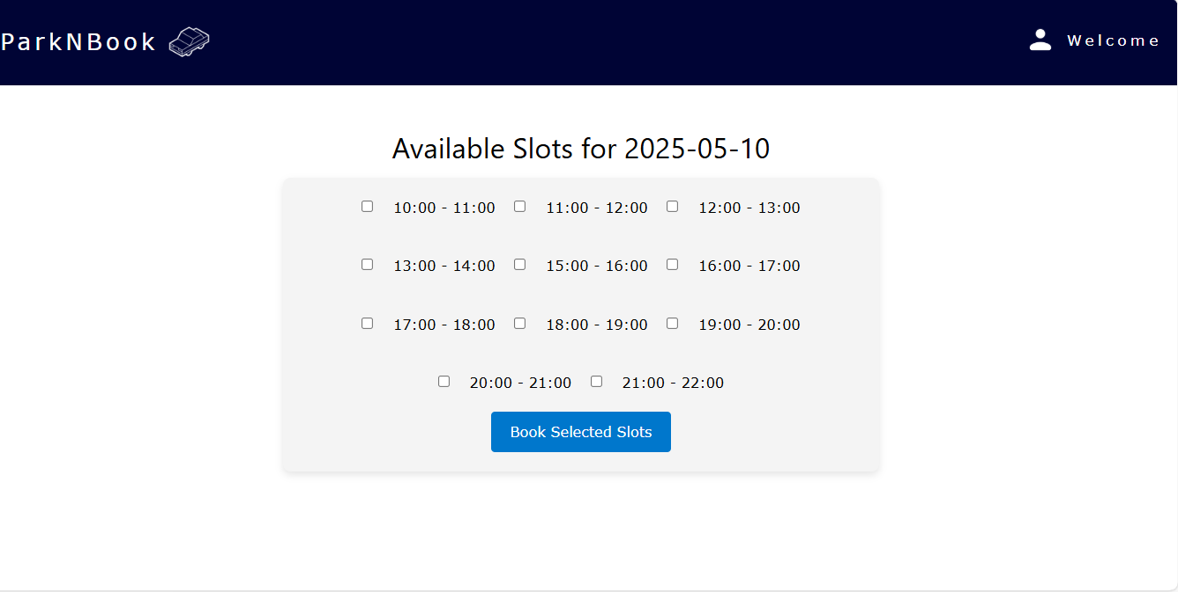

Figure 6
This is the payment page where customers choose a payment method.
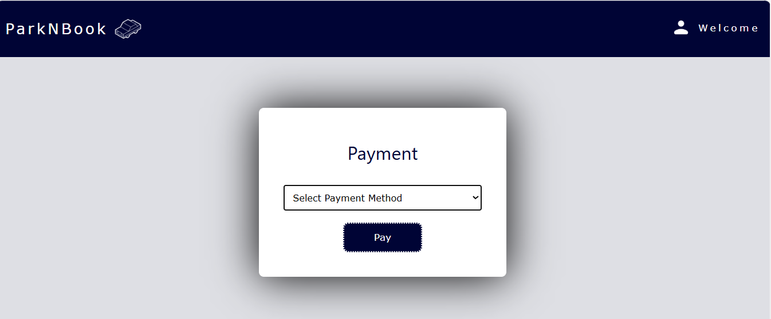

Figure 7
Enables users to submit feedback or suggestions about the system and services.
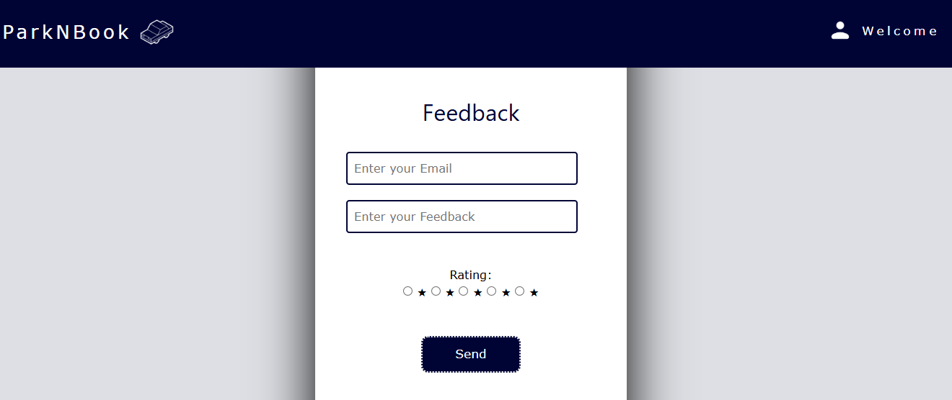

Figure 8
Provides information about the platform’s goals.
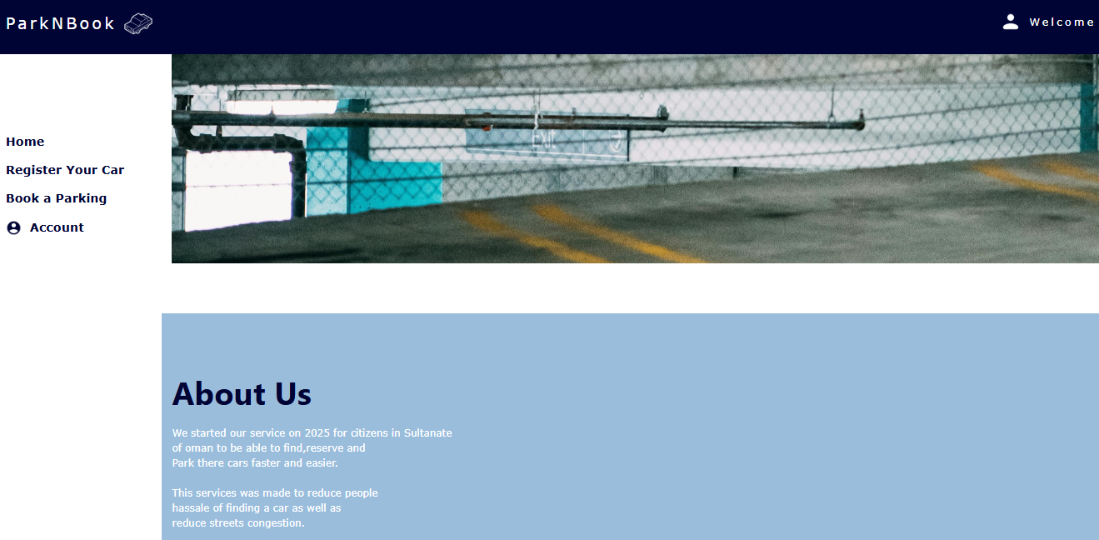

Figure 9
Confirms successful booking or action with a thank-you message to the customer.
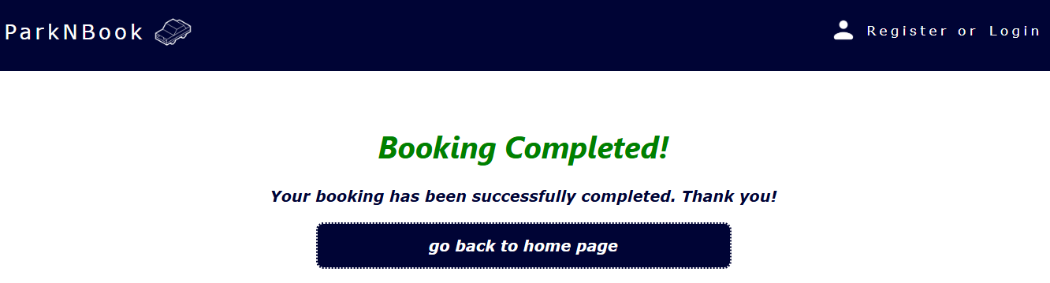

Figure 10
Allows administrators to oversee all customer and parking details and update what's needed.

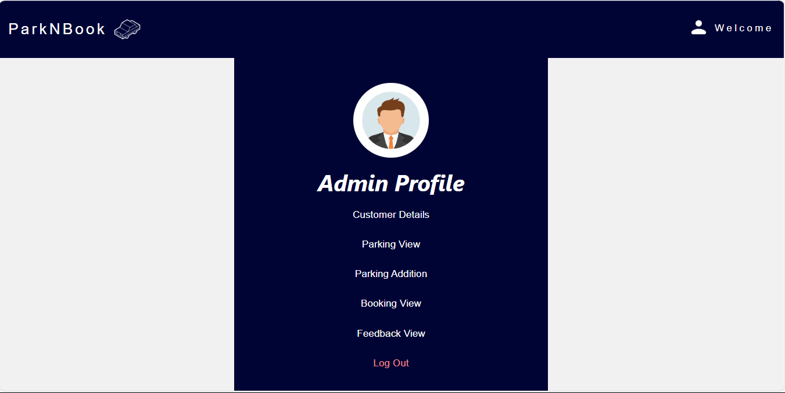
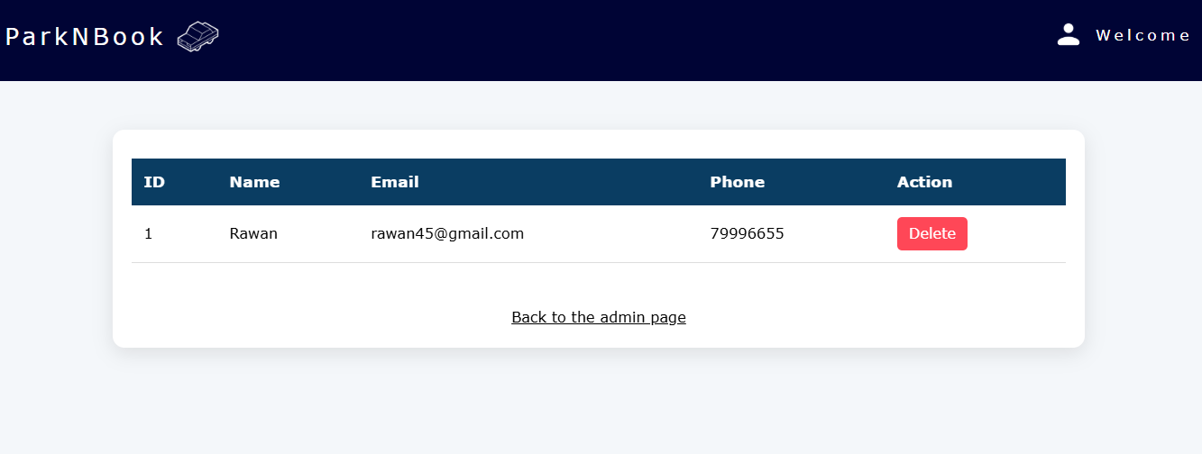
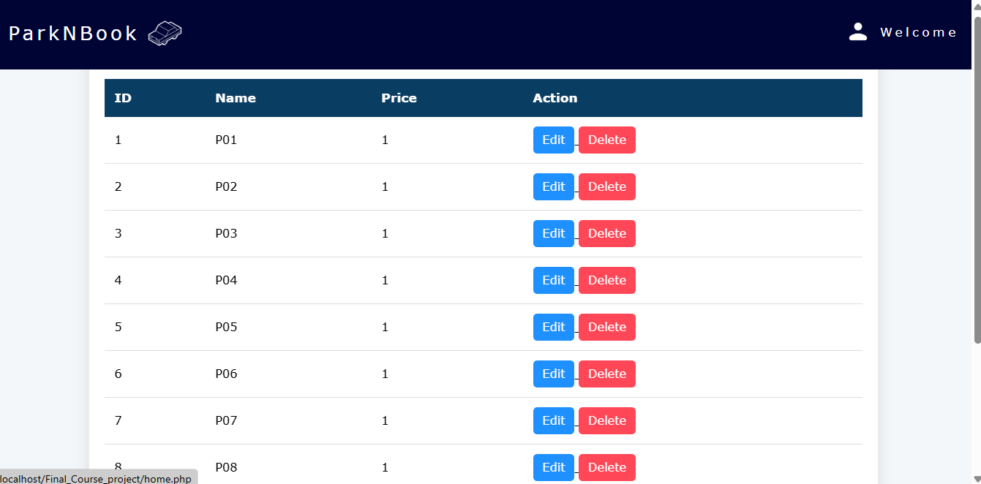
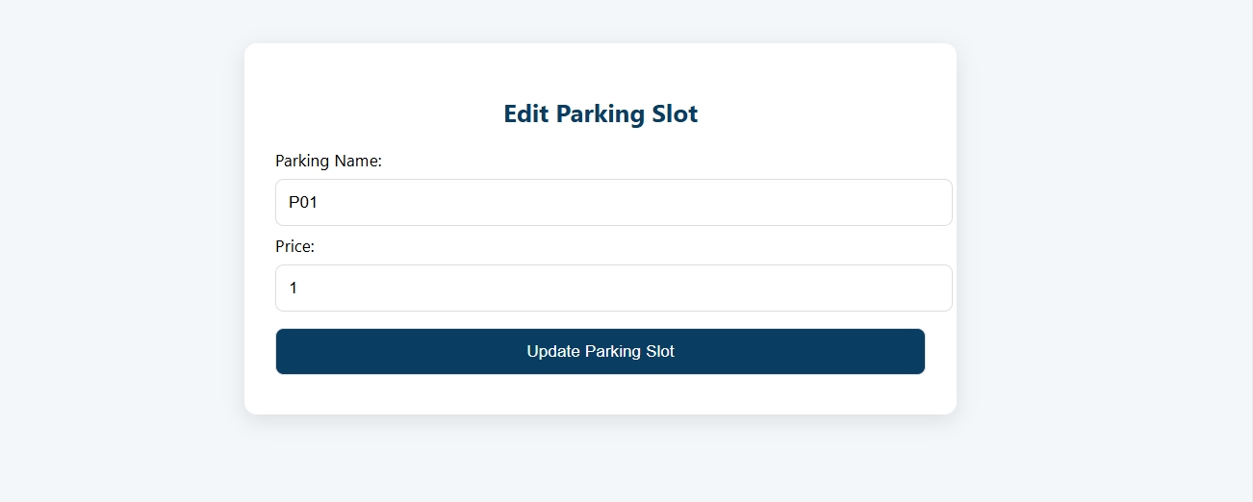

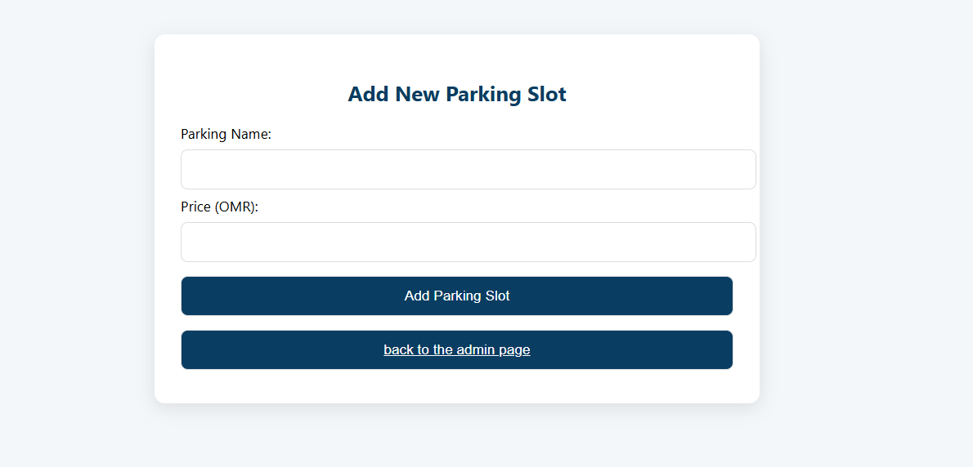
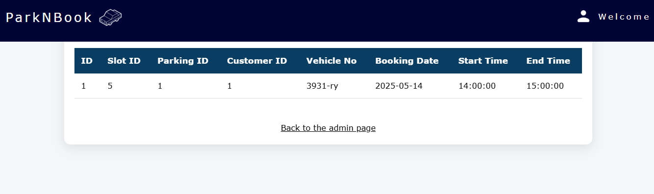

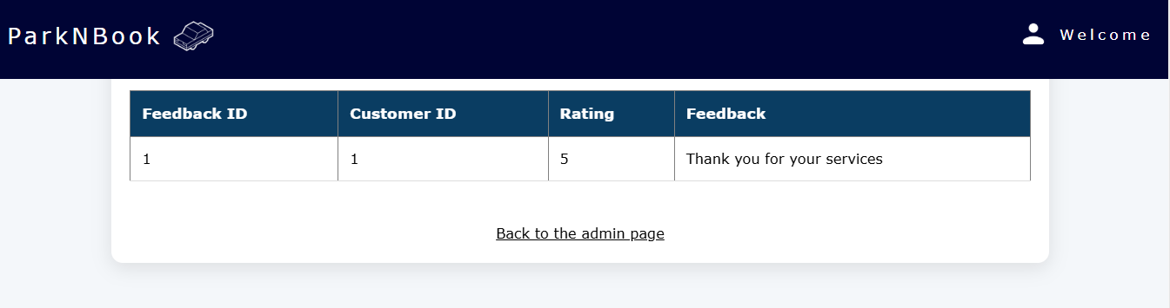

Coding
Register page
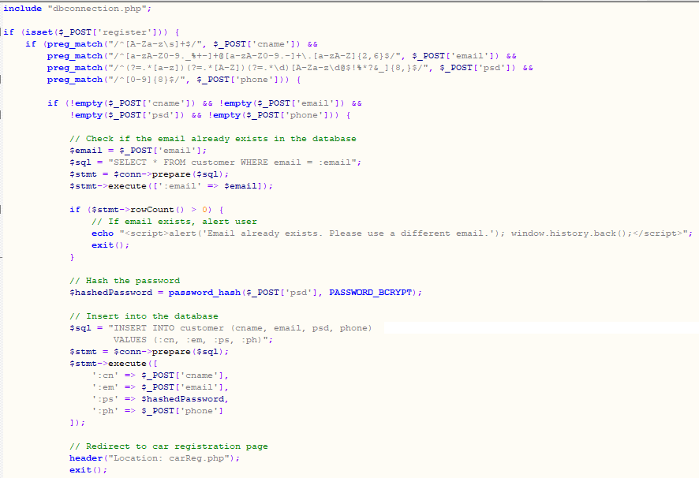
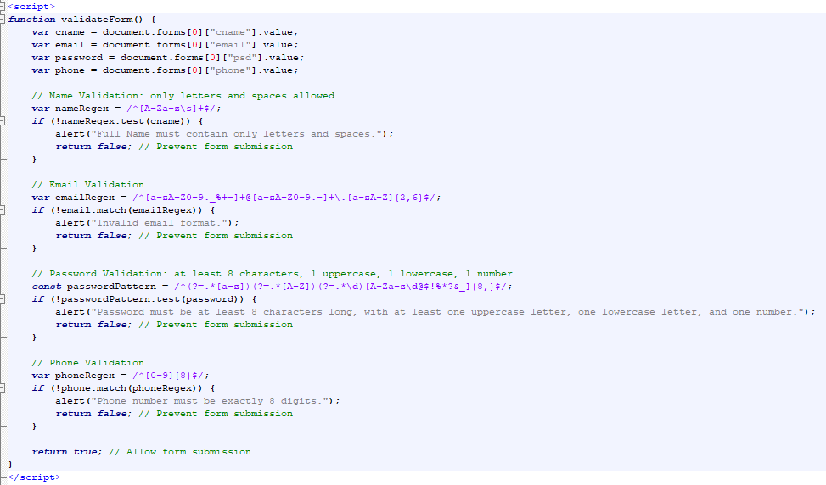
Login page
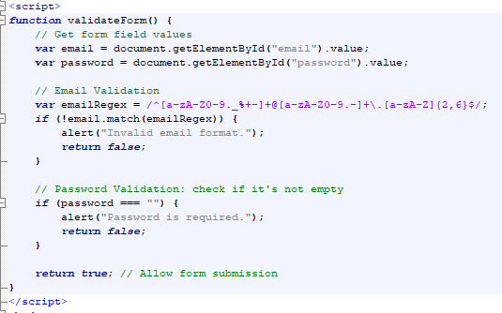
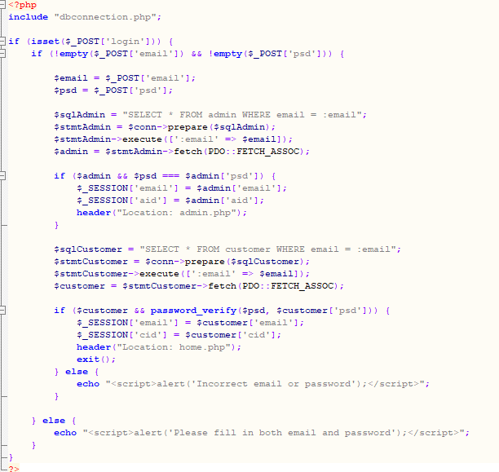

Admin page
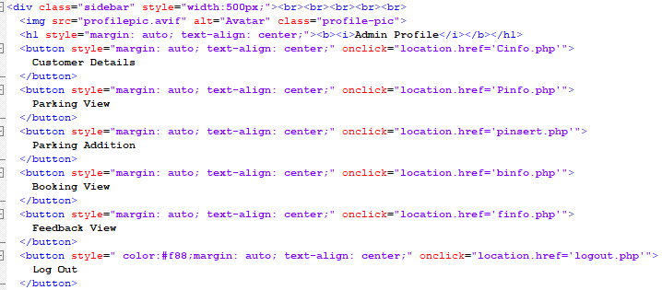
Parking
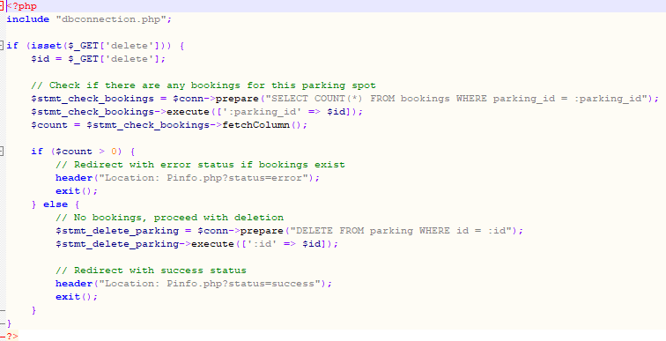
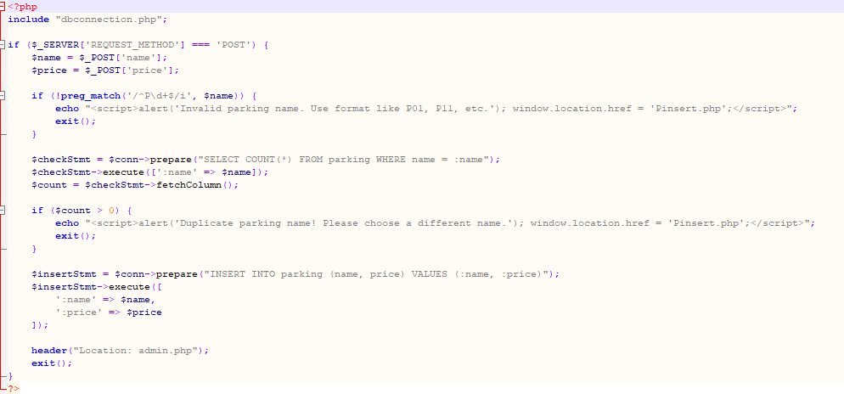
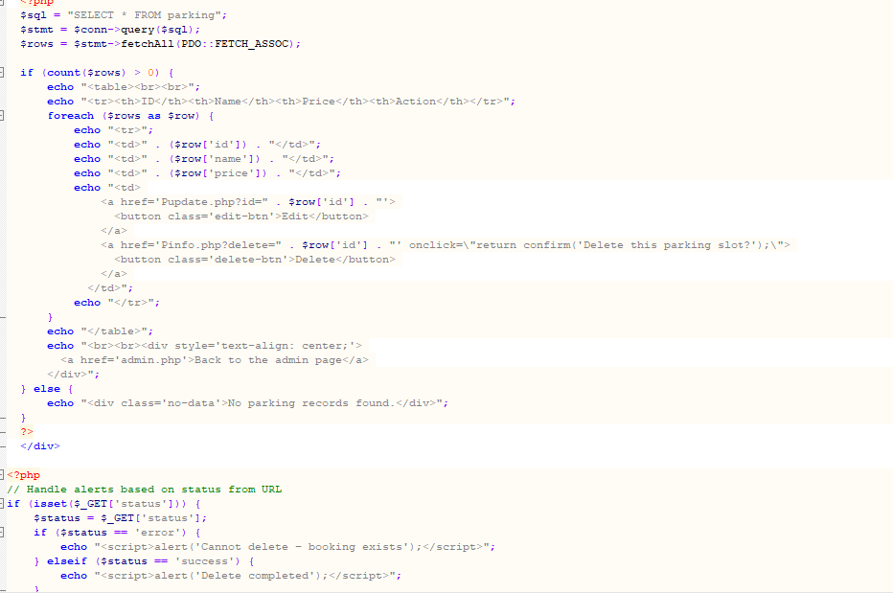

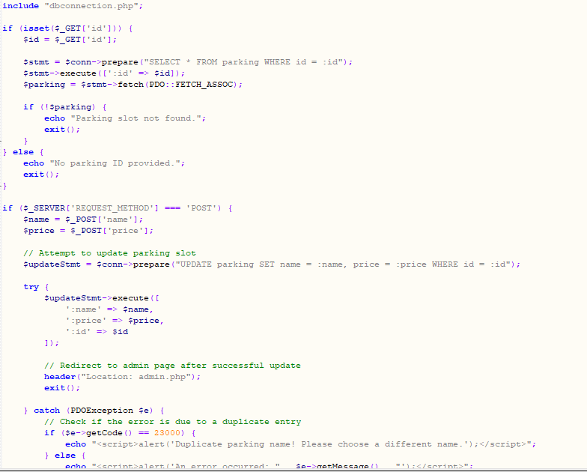
Customer
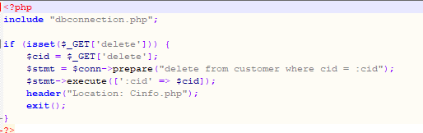
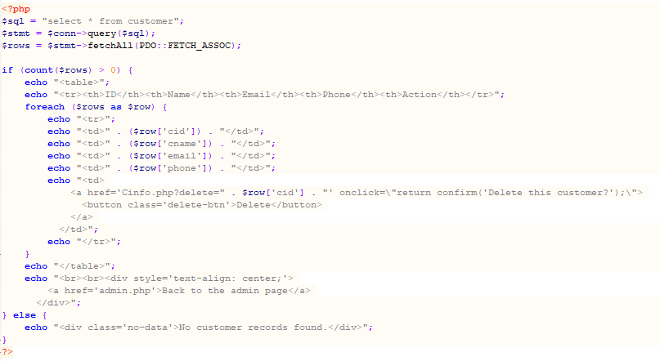
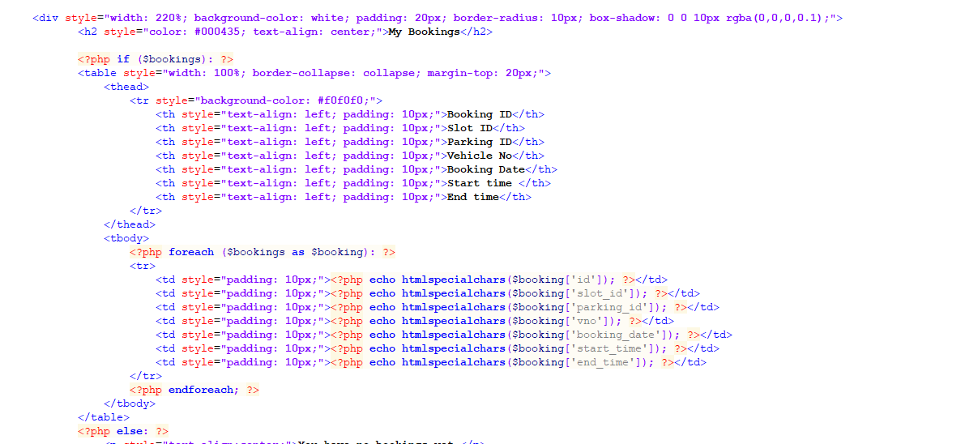
Bookings
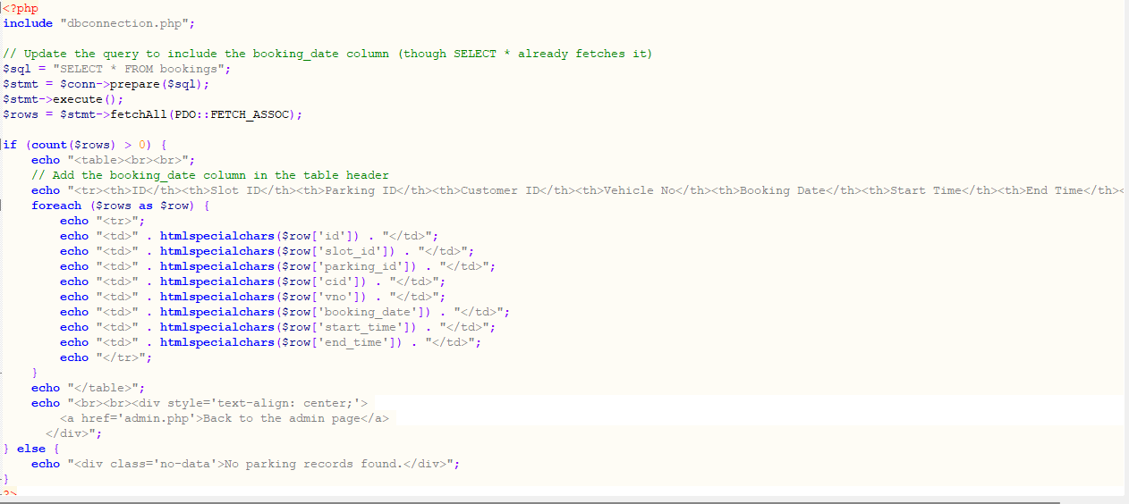

Feedback
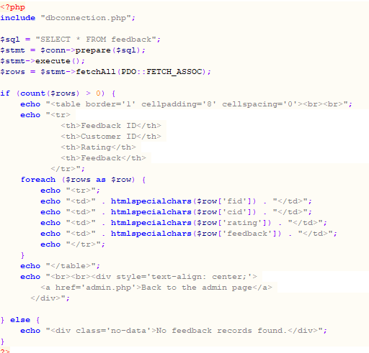

Feedback page-
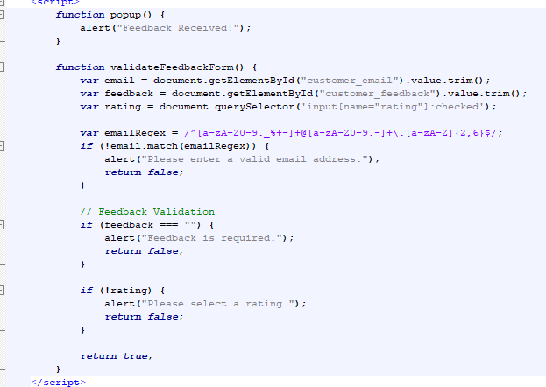
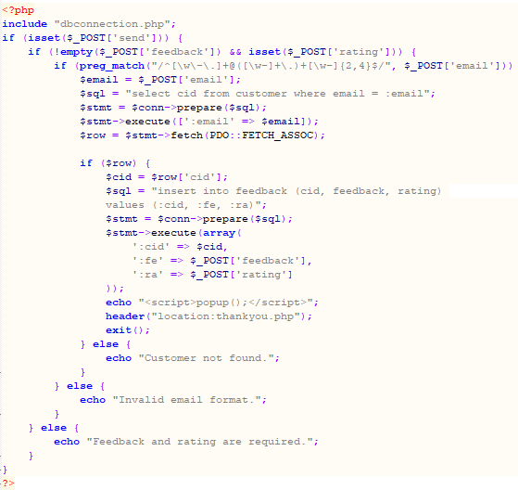

Search/Booking page-
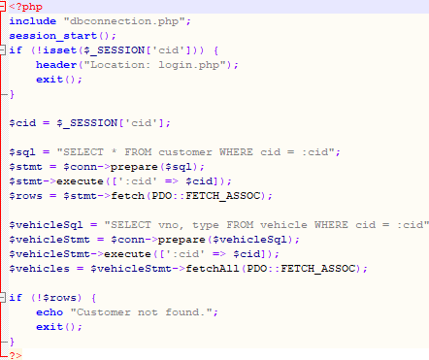

Book slot page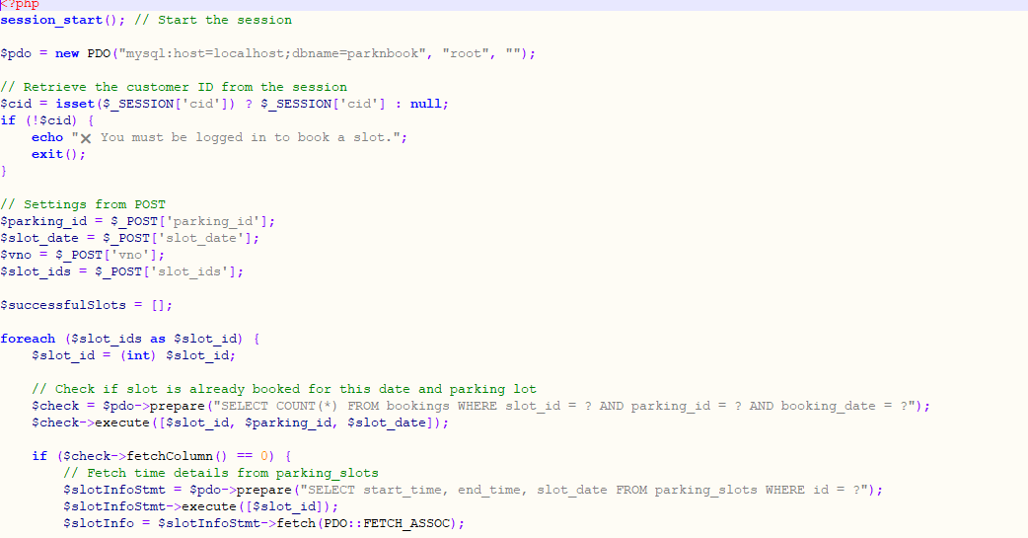
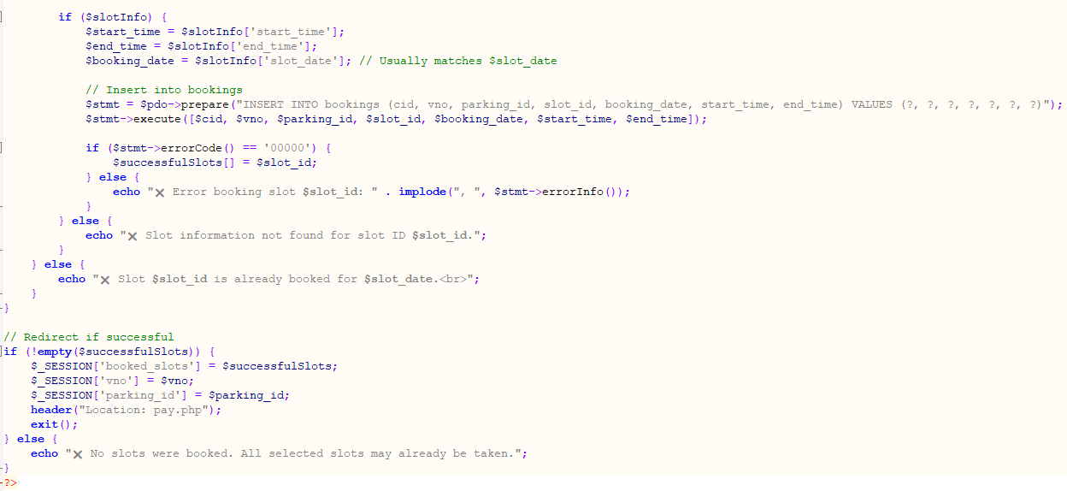
Available slot page
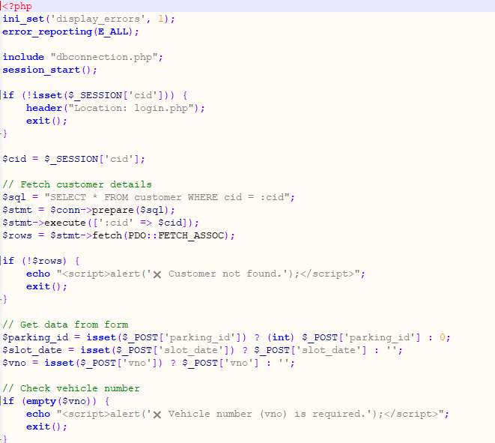
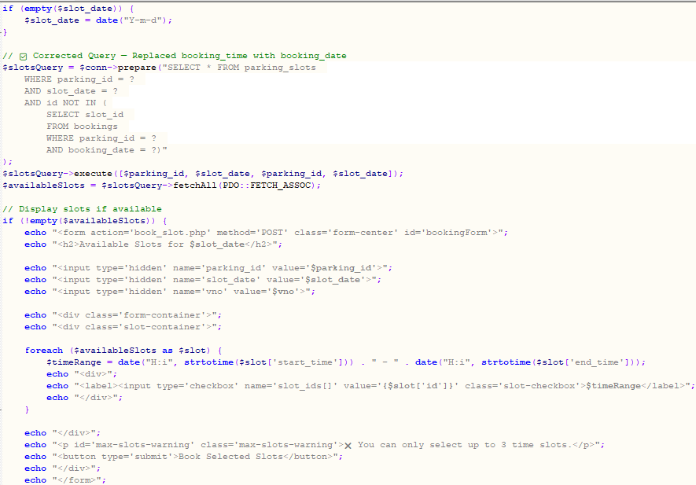

Chapter 6: Testing

6.1 Introduction/Concepts
In this section, testing is conducted to ensure that all system functionalities are working correctly, enabling smooth customer interaction. This includes verifying that the registration, login, booking, admin, and feedback processes are intuitive and efficient. Additionally, testing ensures administrators can use the system effectively to manage the overall platform. Through this process, we aim to identify and resolve any issues that may arise, providing a seamless experience for both customers and administrators.

6.2 Final test cases

Project Name: Parking Booking System
Test Case ID: 1 | Student ID and Signature:  Supervisor Signature:
Module Name: Registration | Test Executed by: Marwa
Test Title: Registration | Test Execution date: 04-05-2025
Description: customer registration

Step | Test Steps | Expected Result | Actual Result | Status (Pass/Fail) | Notes
1 | Customers register all fields with correct information. | Register successfully. | Go to the login Page. | Pass | Email is validated(unique)
2 | Customers register with the wrong validations. | Receive error prompt. | Receive error prompt. | Pass
3 | Customers register with an unfilled field. | Receive the required message. | Register successfully. | Pass
4 | Customers register with unacceptable field validation. | Receive error prompt. | Register successfully. | Pass

Project Name: Parking Booking System
Test Case ID: 2 | Student ID and Signature:  Supervisor Signature:
Module Name: Login | Test Executed by: Team member 2
Test Title: Login | Test Execution date: 05-05-2025
Description: Customer Login

Step | Test Steps | Expected Result | Actual Result | Status (Pass/Fail) | Notes
1 | Customers enter the correct email and password | Login successful, redirect to home page. | Redirect to the home page. | Pass
2 | Customers enter an incorrect email or password | Show error message | Login successfully. | Pass
3 | Customers enter an email with the wrong format | Show validation error | Logged in with the wrong email format | Pass
4 | Customers try to log in with an unregistered email | Show validation error | Receives the error message | Pass

Project Name: Parking Booking System
Test Case ID: 3 | Student ID and Signature:  Supervisor Signature:
Module Name: Admin Management | Test Executed by: Team member 3
Test Title: Admin | Test Execution date: 10-05-2025
Description: Admin Management

Step | Test Steps | Expected Result | Actual Result | Status (Pass/Fail) | Notes
1 | Admin logs into the system with valid credentials. | Login successful. | Admin homepage is shown with full access. | Pass
2 | Admin clicks “Edit” on a parking detail and updates the info. | Parking detail is updated successfully | Error saving data. | Pass
3 | Admin navigates to User Profiles. | List of users is shown. | List of users is shown. | Pass
4 | Admin tries to update parking with invalid data, like empty fields. | error message appears. | Validation error message appears. | Pass | Add, update, delete validated

Project Name: Parking Booking System
Test Case ID: 4 | Student ID and Signature:  Supervisor Signature:
Module Name: Feedback | Test Executed by: Team member 4
Test Title: Feedback | Test Execution date: 12-05-2025
Description: Customer Feedback

Step | Test Steps | Expected Result | Actual Result | Status (Pass/Fail) | Notes
1 | Customer submits valid email, feedback, and rating | Feedback submitted successfully  confirmation message shown | Confirmation message displayed | pass | Saved in the database
2 | Customer submits feedback without an email | Show validation error | Validation error message appears.
3 | Customer submits feedback with an invalid email format | Show validation error | No validation shown, feedback submitted
4 | Customer submits feedback without selecting a rating | An error message appears. | An error message appears.
5 | Customer submits feedback without writing any feedback text | An error message appears. | An error message appears.
6 | Customer enters a valid email and rating but leaves the feedback empty | An error message appears. | Feedback submitted

Project Name: Parking Booking System
Test Case ID: 5 | Student ID and Signature:  Supervisor Signature:
Module Name: Booking | Test Executed by: Team member 5
Test Title: Booking | Test Execution date: 12-05-2025
Description: Customer Booking

Step | Test Steps | Expected Result | Actual Result | Status (Pass/Fail) | Notes
1 | Customer search for parking by choosing from the available lists. | Redirect to available time slots page. | Redirect to available time slots page. | pass | Releasing of slot is done in event 24 HR
2 | Customer search for parking without choosing a vehicle. | Show required message. | Redirect to available time slots page. | pass
3 | Customer book without choosing time. | Does not allow booking. | Does not allow booking. | pass

Chapter 7: Conclusion and Future Work
To conclude, our web-based parking booking system is an easy-to-use and effective platform that assists users in locating and reserving parking spaces online easily. By eliminating the inconvenience and tedious task of manually searching for parking, our system improves the entire parking experience. With only a few clicks, users can see available spaces, secure their bookings safely, and benefit from a more efficient, organized parking procedure.

Future work-
- Integrate smart locks with the website to manage parking spaces more efficiently.
- Implement AI solutions for real-time parking availability detection and provide GPS-based routes to the parking location.
- Add a customer support chatbot to assist users with their bookings and inquiries.
- Introduce a waiting list feature, allowing customers to join a queue and automatically receive a spot if a booking is canceled.
- The payment system will integrate PayPal, Apple Pay, and local bank payment options, allowing users to easily pay for parking bookings through secure, simple transactions.

Chapter 8: Roles and Contributions of the Student Group
Members | Contribution In Project
Leader-Marwa | 2.1 Background study  3.1 Action Plan  3.2 Tracing Sheet  4.1 Data Flow Diagram  4.5 Navigation Diagram  5.1 Screen Design with Navigation Links  6.2 Final test cases
Team member 5 | 1.7 Project Methodology  4.2 Normal forms  5.1 Screen Design with Navigation Links  6.2 Final test cases
Team member 4 | Introduction  1.2 Problem Statement  4.3 Table Design  5.1 Screen Design with Navigation Links  6.2 Final test cases
Team member 3 | 1.4 Project Objectives  2.2 Hardware requirements  2.3 Software requirements  2.4 Functional Requirement  2.5 Non-Functional Requirement  3.3 Questionnaires with analysis  6.2 Final test cases
Team member 2 | 1.5 Project Description  1.6 Significance of the project  4.4 Entity Relationship Diagram (ERD)  5.1 Screen Design with Navigation Links

Appendices-
- Context Level: Level Zero.
- Table design: Table Structure.

References-
- Andrea. (2020, August 3). SpotHero insurance and parking tips. Retrieved on March 12, 2025 from https://blog.spothero.com/insurance-and-parking/
- Parclick. (n.d.). City centre, airport, station and beach parkings | Parclick. Retrieved on March 12, 2025 from https://parclick.com/
- Lucidchart. (2025). Lucidchart: Diagrams for everyone. Lucidchart. https://www.lucidchart.com/pages
- https://docs.google.com/forms/u/0/
- https://erdplus.com/

